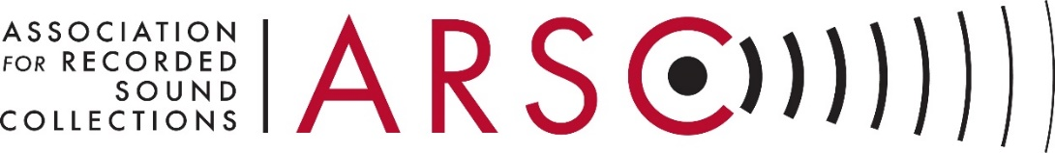

CALL FOR NOMINATIONS OF CANDIDATES FOR ARSC AWARDS JUDGES
The Association for Recorded Sound Collections seeks nominations of candidates to stand for election to the following positions on the ARSC Awards Committee:
Judge with expertise in Recorded Classical Music
Judge with expertise in Recorded Jazz Music
Judge with expertise in Recorded Popular Music
Judge-at-Large (2) with expertise in any field of Recorded Sound

The ARSC Awards Committee confers the ARSC Awards for Excellence in Historical Recorded Sound Research, the new ARSC Award for Creative Use of Historical or Archival Sound, and the ARSC Service Awards, which include the ARSC Distinguished Service to Historical Recordings Award and the ARSC Lifetime Achievement Award.
Service on the ARSC Awards Committee is an opportunity to review the very best work in recorded sound research; recognize those who excel in research and publication; encourage others to emulate their high standards; and promote readership of their work.
ARSC Awards Committee Judges stand for election by the ARSC membership and serve two-year terms. Judges review works in their categories and contribute to committee deliberations.
Judges do not need to be ARSC members, but should have recognized expertise and prominence in their areas of interest. The two Judges-at-Large may have recognized expertise in any field of recorded sound.
To nominate yourself or another please notify an ARSC Nominating Committee member listed below as soon as possible, or by November 2018. Please provide a brief justification for your nomination.
Thank you. We are looking forward to hearing from many of you!
– ARSC Nominating Committee

Danielle Cordovez, Chair <daniellecordovez@nypl.com>
Patrick Feaster <pfeaster@indiana.edu>

